**ADDITION USING 8086 PROCESSOR**

**Expt:no:33**

**AIM**: To write an assembly language program to implement addition using 8086 processor.

**ALGORITHM:**

**1.** Load the first data in AX register.

2. Load the second data in BX register.

3. Clear CL register.

4. Add the two data and get the sum in AX register.

5. Store the sum in memory.

6. Check for carry. If carry flag is set then go to next step, otherwise go to 8th step.

7. Increment CL register.

8. Store the carry in memory.

9. Stop.

**PROGRAM**:

MOV AL, 06H

MOV BL, 0AH

ADD BL, AL

MOV CX,00008H

PRINT: MOV AH,02H

MOV DL,030H

TEST BL,080H

JZ ZERO

MOV DL,031H

ZERO: INT 021H

SHL BL,1

LOOP PRINT

MOV DL,062H

INT 021H

MOV AH,00H

INT 016H

RET

NOP

NOP

NOP

RET

**OUTPUT:**

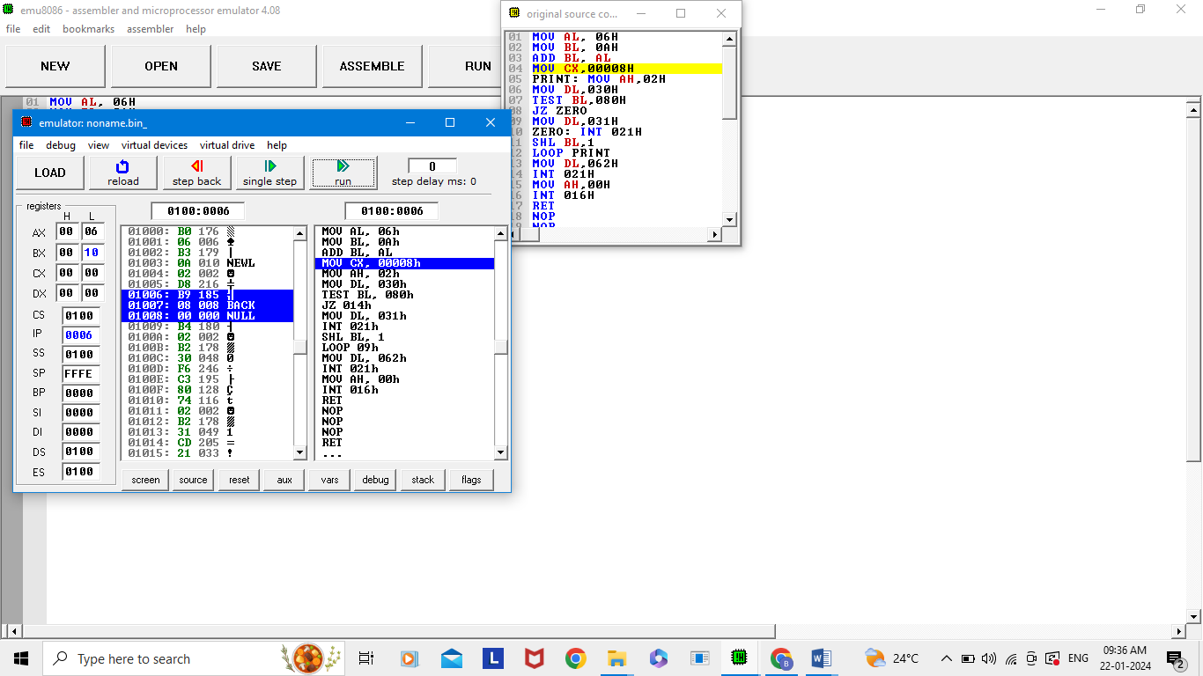

**RESULT:** Thus the program is implemented successfully using8086 processor.